Dear teachers,

Below, you’ll find three editable templates for assigning LearnArgument.com to your students as “summer reading.” Some important things for you to know about these templates:

The first assignment template is designed to guide students through the process of signing in after you’ve invited them to your class. If your school is paying for students’ accounts, this is the easiest way to add students. From your teacher dashboard, you’ll see a dropdown button called “users” that looks like this:

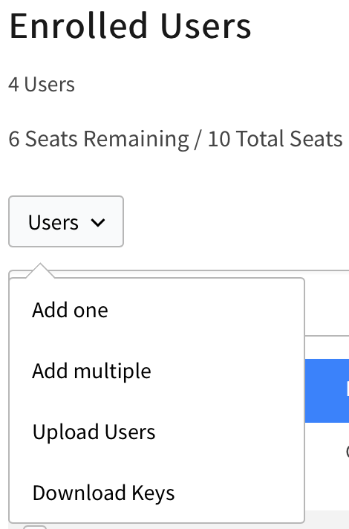

Once you click on that button, you can easily add your students to your class. This will get them full access to the course and will ensure that they’re linked to your dashboard so that you can monitor their progress. (Yes, it’s that easy.) We recommend that you select the “Add and invite user” option, because that will automatically create the student’s account. The first assignment template explains this process to students.

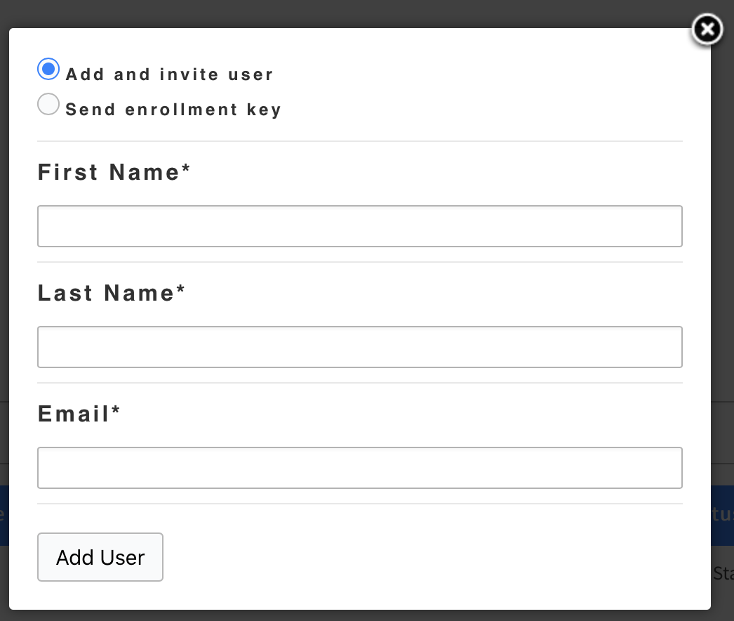

Another option is to send students an enrollment key. This does not automatically create student accounts. Instead, it emails students a special code that they can use to register themselves at learnargument.com/enroll. We recommend the “Add and invite user” option… but, if you’d prefer to send students enrollment keys, the second assignment template (below) provides the corresponding instructions for students.

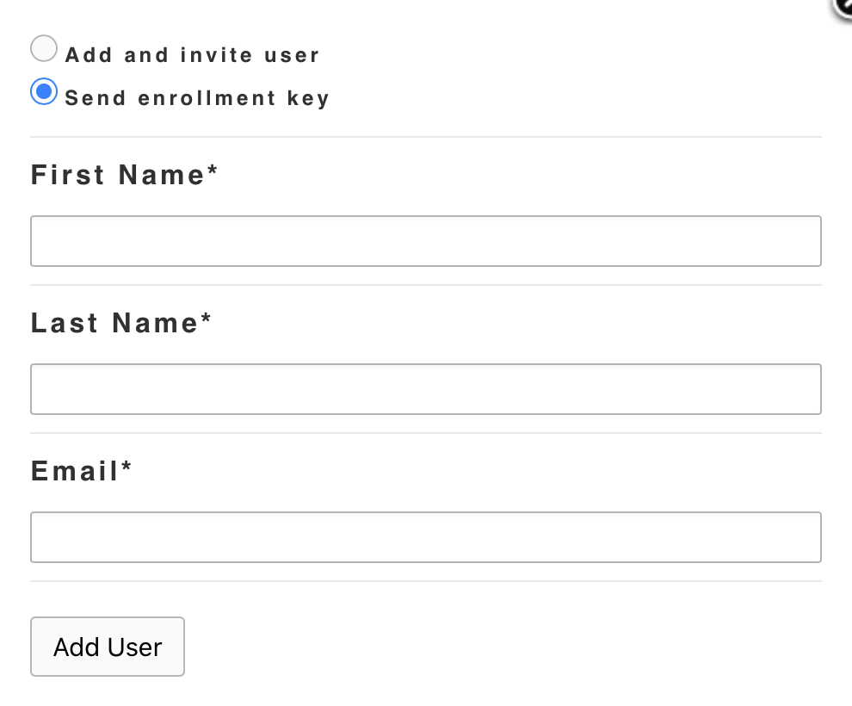

The third and final template (below) is designed to guide students through the process of registering and paying for themselves.

Select the template that best reflects your needs! These templates are fully editable, so if there’s any language you’d like to tweak… any additional information you’d like to add… or any additional summer work you’d like to assign… that should be a piece of cake.

We’ve highlighted fields for you to personalize, including places to enter your name, email address, and so on.

Enjoy!

LearnArgument

[==Delete This Text – Template for Students You’ve Manually Added to Your Class==]
Summer Assignment for [**Your Name / Your Class Here**]

Dear students,

This year’s “summer reading” is likely going to look and feel a little different than it has in previous years. Rather than to put some books in your hands and send you on your merry way, you are being asked to complete a series of online learning modules over the course of the summer months. The point of this is to help you develop the skills that you’ll need in order to flourish in our class – and when the start of the school year rolls around, you’ll find yourself better prepared than ever before.

The focus of your summer assignment is “argument,” which is basically the art of using language in purposeful ways to make an impact on a target audience. Most speeches are obvious examples – for instance, when a politician makes a campaign speech in an effort to gain more votes, or when a protester speaks out at a rally in support of a cause. But arguments can take many forms, and those that you’ll be examining this summer include pop songs, music videos, and advertisements. (Bet you didn’t expect to be analyzing Billie Eilish, Selena Gomez, and Post Malone for “summer reading,” did you…)

Here’s what you need to do in order to get started:

Step 1. I’ve registered (or, I will soon be registering) you to our online learning experience at
LearnArgument.com. Check your inbox for an invitation email that includes your login credentials
and your password.

Step 2. Use those credentials to sign in at https://learnargument.com/login. You can do this from any web
browser. Laptops, tablets, and phones all work! If your home technology isn’t cooperating, you may utilize the computers and Wi-Fi at the public library.

Step 3. That’s it! You’re in! Time to roll up your sleeves and dig in!

The online course that you’ll be completing is broken down into six modules. Most modules are designed to be completed over the course of a week – so, in order to optimize your learning, you are encouraged to start this early and to complete the course over the course of about six weeks. That said, the course is self-paced, so you’ll be able to move more quickly or slowly through the online learning modules depending on your own preferences.

When you finish the course, you’ll receive a certificate of completion – which you must print out and bring to class on the first day of school. You must also be prepared to put your newly learned skills to work during the first week of school.

If you have any questions at all, you may reach out to me via email at [**your email**]… and, should you run into any technical difficulties with the course or website, you can contact help@learnargument.com.

Good luck, and have a great summer!

[==Delete This Text – Template for Students You’ve Emailed Registration Keys==]
Summer Assignment for [**Your Name / Your Class Here**]

Dear students,

This year’s “summer reading” is likely going to look and feel a little different than it has in previous years. Rather than to put some books in your hands and send you on your merry way, you are being asked to complete a series of online learning modules over the course of the summer months. The point of this is to help you develop the skills that you’ll need in order to flourish in our class – and when the start of the school year rolls around, you’ll find yourself better prepared than ever before.

The focus of your summer assignment is “argument,” which is basically the art of using language in purposeful ways to make an impact on a target audience. Most speeches are obvious examples – for instance, when a politician makes a campaign speech in an effort to gain more votes, or when a protester speaks out at a rally in support of a cause. But arguments can take many forms, and those that you’ll be examining this summer include pop songs, music videos, and advertisements. (Bet you didn’t expect to be analyzing Billie Eilish, Selena Gomez, and Post Malone for “summer reading,” did you…)

Here’s what you need to do in order to get started:

Step 1. I’ve registered (or, I will soon be registering) you to our online learning experience at
LearnArgument.com. Check your inbox for an invitation email that includes your unique
registration code.

Step 2. Visit https://learnargument.com/enroll. Enter your credentials (name, email, and registration code)
before submitting the form.

Step 3. That’s it! You’re in! Time to roll up your sleeves and dig in!

The online course that you’ll be completing is broken down into six modules. Most modules are designed to be completed over the course of a week – so, in order to optimize your learning, you are encouraged to start this early and to complete the course over the course of about six weeks. That said, the course is self-paced, so you’ll be able to move more quickly or slowly through the online learning modules depending on your own preferences.

When you finish the course, you’ll receive a certificate of completion – which you must print out and bring to class on the first day of school. You must also be prepared to put your newly learned skills to work during the first week of school.

If you have any questions at all, you may reach out to me via email at [**your email**]… and, should you run into any technical difficulties with the course or website, you can contact help@learnargument.com.

Good luck, and have a great summer!

[=Delete This Text – Template for Asking Students to Register & Pay For Themselves=]
Summer Assignment for [**Your Name / Your Class Here**]

Dear students,

This year’s “summer reading” is likely going to look and feel a little different than it has in previous years. Rather than to put some books in your hands and send you on your merry way, you are being asked to complete a series of online learning modules over the course of the summer months. The point of this is to help you develop the skills that you’ll need in order to flourish in our class – and when the start of the school year rolls around, you’ll find yourself better prepared than ever before.

The focus of your summer assignment is “argument,” which is basically the art of using language in purposeful ways to make an impact on a target audience. Most speeches are obvious examples – for instance, when a politician makes a campaign speech in an effort to gain more votes, or when a protester speaks out at a rally in support of a cause. But arguments can take many forms, and those that you’ll be examining this summer include pop songs, music videos, and advertisements. (Bet you didn’t expect to be analyzing Billie Eilish, Selena Gomez, and Post Malone for “summer reading,” did you…)

Here’s what you need to do in order to get started:

Step 1. Visit to LearnArgument.com. You can do this from any web browser. If your home technology
isn’t cooperating, you may utilize the computers and Wi-Fi at the public library.

Step 2. Click on the green button that says, “I’M A STUDENT.”

Step 3. Click on the button that says, “I DON’T HAVE A REGISTRATION CODE.”

Step 4. You’ll notice that a signup screen appears with the charge of $15.00 to register. This is about the
cost of a summer reading book – but much more effective in terms of getting you ready for our class.

Step 5. Complete the registration process to create your account – and you’re in!

The online course that you’ll be completing is broken down into six modules. Most modules are designed to be completed over the course of a week – so, in order to optimize your learning, you are encouraged to start this early and to complete the course over the course of about six weeks. That said, the course is self-paced, so you’ll be able to move more quickly or slowly through the online learning modules depending on your own preferences.

When you finish the course, you’ll receive a certificate of completion – which you must print out and bring to class on the first day of school. You must also be prepared to put your newly learned skills to work during the first week of school.

If you have any questions at all, you may reach out to me via email at [**your email**]… and, should you run into any technical difficulties with the course or website, you can contact help@learnargument.com.

Good luck, and have a great summer!

